 | AWARDS BY AGE GROUP  Rotary Bug Run 5K Run/Walk  August 20, 2022 | 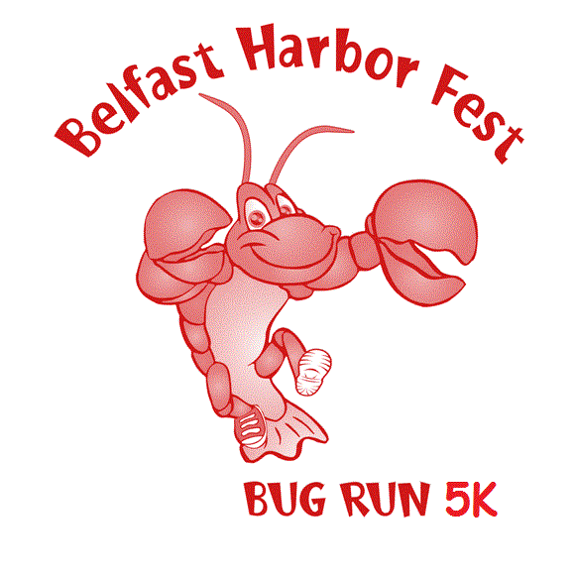
MALE |  |  |  | FEMALE
BIB | NAME | TIME | GROUP | BIB | NAME | TIME
377 | Carl Hartford | 16:02 | Overall | 317 | Melanie Walker | 21:44
343 | Fitz Courtney | 18:55 | < 14 | 306 | Emily Barnett | 34:11
378 | Ethan Bruce | 20:51 | 15 - 19 |  | None
333 | Aymen Langlois | 19:37 | 20 - 29 | 396 | Meaghan Gilbert | 32:21
239 | Teddy Mattson | 20:09 | 30 - 39 | 390 | Caitlan May | 21:52
373 | Matt Molison | 17:38 | 40 - 49 | 308 | Rachael Tulchin | 22:06
382 | Brett Almasi | 21:24 | 50 - 59 | 321 | Maryann Ekberg | 28:27
395 | Jerry Goldstein | 21:08 | 60 - 69 | 339 | Juliana King | 29:47
224 | Steve Kearney | 29:00 | 70 - 79 | 398 | Bernadette Geller | 39:58
 | None |  | > 80 | 365 | Barbara Brockman | 58:09

